Encryption & Decryption (Caesar Cipher)

Name: Kritika Grover
Course: Bachelor of Computer Applications (BCA)
Project: Encryption & Decryption (Caesar Cipher)
Technology: Python

Aim
To develop a Python program that encrypts and decrypts text using the Caesar Cipher technique to demonstrate the basics of cryptography.

Objective
To understand encryption and decryption concepts, implement the Caesar Cipher, and display both encrypted and decrypted text.

Tools Used
• Python 3
• Visual Studio Code
• Windows Operating System

Concepts Used
• Variables
• User Input
• for Loop
• if-else Statements
• String Handling
• Caesar Cipher
• ASCII (ord() and chr())

Algorithm
1. Start the program.
2. Accept text from the user.
3. Accept the shift value.
4. Encrypt each alphabetic character.
5. Display the encrypted text.
6. Decrypt the encrypted text using the same shift.
7. Display the decrypted text.
8. End the program.

Flowchart
Start → Input Text → Input Shift Value → Encrypt Text → Display Encrypted Text → Decrypt Text → Display Decrypted Text → End

Advantages
• Easy to understand.
• Demonstrates basic cryptography.
• Preserves non-alphabetic characters.
• Helps learn encryption logic.

Limitations
• Caesar Cipher is not secure for real-world applications.
• Can be broken using brute force.
• Uses a fixed shift value.

Future Scope
Enhance the project by allowing custom encryption methods, implementing the Vigenère Cipher, adding a graphical user interface, or using stronger cryptographic algorithms.

Python Code

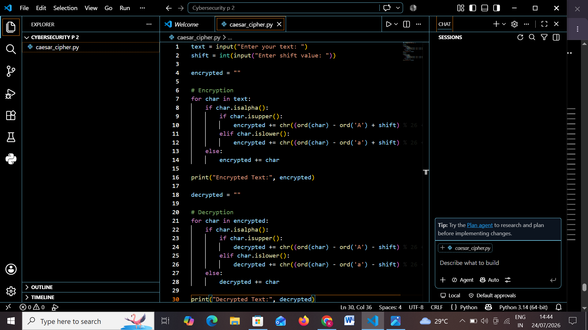

Output Screenshots

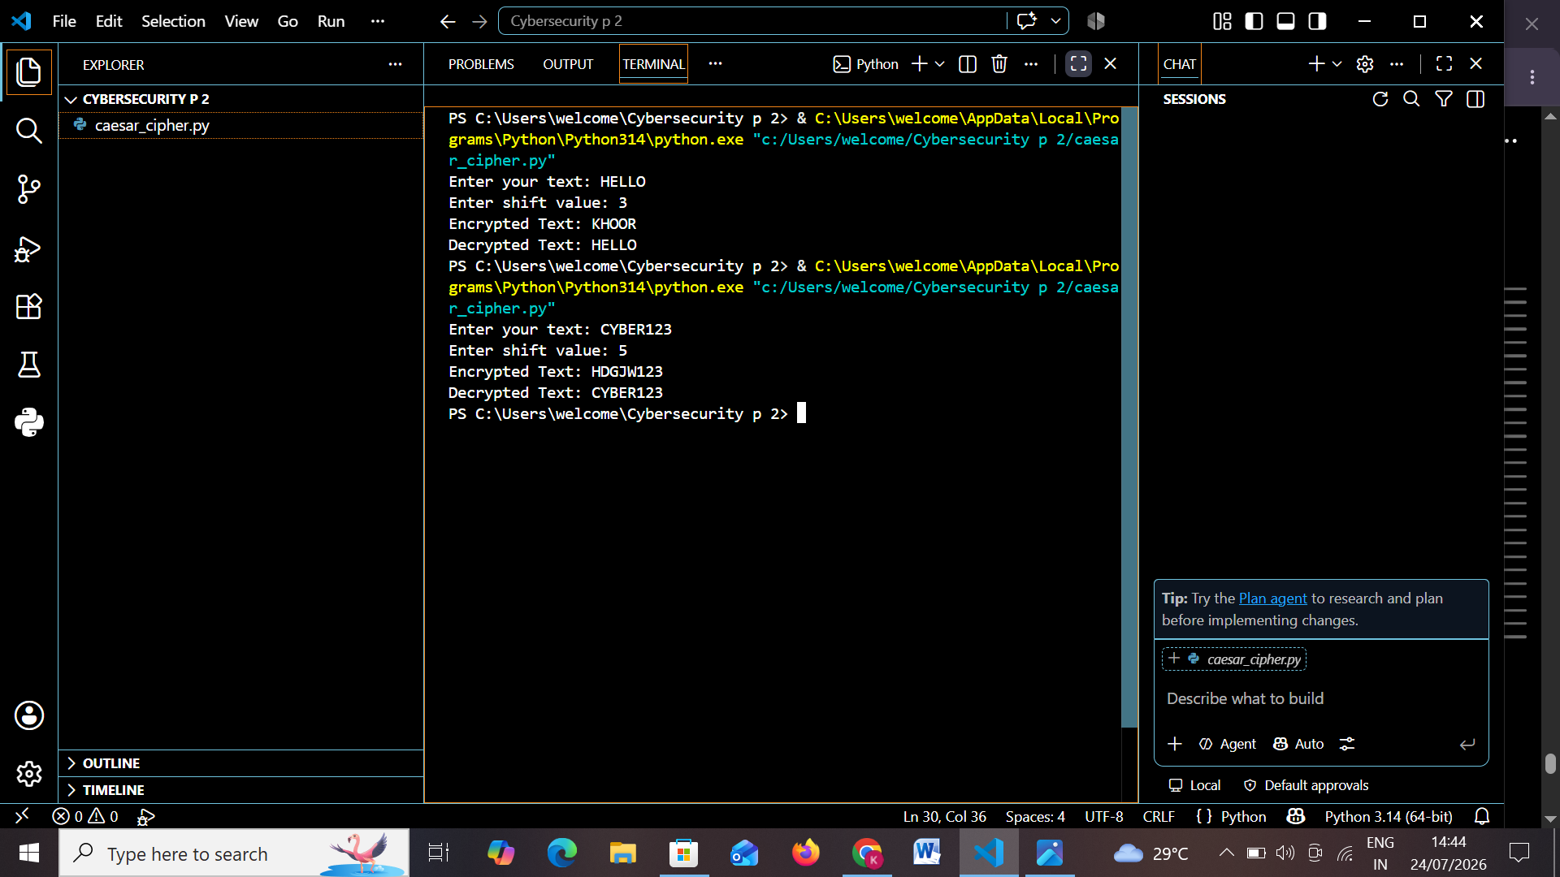


Conclusion
The project successfully encrypts and decrypts text using the Caesar Cipher algorithm, helping users understand the fundamentals of data confidentiality and basic cryptography.

